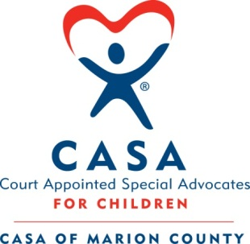
CASA of Marion County
112 Adams St. Room 203, Fairmont, WV 26554
Phone: 304-366-4198 Fax: 304-366-4695
mccasa@wvdsl.net

“We believe in the power of volunteers making a difference in the
lives of abused and neglected children”

CASA of Marion County
BOARD OF DIRECTORS
Application for Membership

In order to be considered, all nominations of potential board members must be accompanied by a completed “Application for Membership.”

ALL APPLICATIONS FOR THE BOARD OF DIRECTORS WILL BE ASSESSED FOR THE DEMOGRAPHIC, ETHNIC AND PROFESSIONAL NEEDS OF THE BOARD OF DIRECTORS. RECEIPT OF A COMPLETED APPLICATION WILL BE REGARDED AS AN EXPRESSION OF INTEREST, NOT AN ACCEPTANCE OR COMMITMENT TO SERVE.
Name: ________________________________ Email _____________________Date: ________
Preferred Mailing Address: ____________________________________
____________________________________
_____________________________________
Daytime Phone Number:________________ Date of Birth (optional):__________________

Occupation: ______________________________Preferred Title: ______________________
Business:_________________________________ Ethnicity (optional) :____________________
Nonprofit Experience: ___________________________________________________________
Education, Training, Special Skills: _________________________________________________
Volunteer Experience: ____________________________________________________________
How long a resident of West Virginia: _______________________________________________
Memberships in other organizations: _________________________________________________
Known by the following board members of this agency: __________________________________
________________________________________________________________________________
Brief biography:__________________________________________________________________________________________________________________________________________________________________________________________________________________________________________
What strengths or skills would you bring to this board: _____________________________________
__________________________________________________________________________________________________________________________________________________________________
Signature of Applicant: Date: ________________________________________________________

Please return to: CASA of Marion County, 112 Adams St. 203, Fairmont, WV 26554

